output: html_document --- Inference on ToothGrowth ## Author: Edward Lau

### Overview: I am going to perform statistical inference on the ToothGrowth dataset in the R datasets package, to ask the question of whether the dose and delivery methods of vitamin C may have a significant effect on the growth of odontoblasts (teeth) in a population of 10 guinea pigs.

### Part 2: Inference

This will load the ToothGrowth dataset, which examines the effect of Vitamin C on tooth growth in guinea pigs. len = length of teeth for 10 guinea pigs; supp = OC or VC delivery methods (orange juice or ascorbic acid); dose = dose level

### Question 1: Load the ToothGrowth data and perform basic exploratory data analyses

library(datasets)  
library(dplyr)

##   
## Attaching package: 'dplyr'  
##   
## The following object is masked from 'package:stats':  
##   
## filter  
##   
## The following objects are masked from 'package:base':  
##   
## intersect, setdiff, setequal, union

library(ggplot2)  
glimpse(ToothGrowth)

## Observations: 60  
## Variables:  
## $ len (dbl) 4.2, 11.5, 7.3, 5.8, 6.4, 10.0, 11.2, 11.2, 5.2, 7.0, 16....  
## $ supp (fctr) VC, VC, VC, VC, VC, VC, VC, VC, VC, VC, VC, VC, VC, VC, ...  
## $ dose (dbl) 0.5, 0.5, 0.5, 0.5, 0.5, 0.5, 0.5, 0.5, 0.5, 0.5, 1.0, 1....

qplot(len, dose, data = ToothGrowth, facets = .~supp)

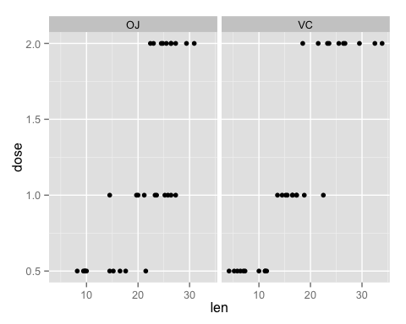 Conclusion: it looks like there are increases in tooth length by doses of OJ and VC.

### Question 2: Summarizing the data by dose and supp.

group_by(ToothGrowth, supp, dose) %>% summarize(mean = mean(len))

## Source: local data frame [6 x 3]  
## Groups: supp  
##   
## supp dose mean  
## 1 OJ 0.5 13.23  
## 2 OJ 1.0 22.70  
## 3 OJ 2.0 26.06  
## 4 VC 0.5 7.98  
## 5 VC 1.0 16.77  
## 6 VC 2.0 26.14

The above table summarizes the mean of tooth length for each dose/ supplement combination.

### Question 3: Compare dose and supplement delivery method using a t test

OJdata_0.5 <-filter(ToothGrowth, supp=="OJ", dose == 0.5)  
VCdata_0.5 <-filter(ToothGrowth, supp=="VC", dose == 0.5)  
t.test(OJdata_0.5$len,VCdata_0.5$len)

##   
## Welch Two Sample t-test  
##   
## data: OJdata_0.5$len and VCdata_0.5$len  
## t = 3.1697, df = 14.969, p-value = 0.006359  
## alternative hypothesis: true difference in means is not equal to 0  
## 95 percent confidence interval:  
## 1.719057 8.780943  
## sample estimates:  
## mean of x mean of y   
## 13.23 7.98

OJdata_1.0 <-filter(ToothGrowth, supp=="OJ", dose == 1.0)  
VCdata_1.0 <-filter(ToothGrowth, supp=="VC", dose == 1.0)  
t.test(OJdata_1.0$len,VCdata_1.0$len)

##   
## Welch Two Sample t-test  
##   
## data: OJdata_1.0$len and VCdata_1.0$len  
## t = 4.0328, df = 15.358, p-value = 0.001038  
## alternative hypothesis: true difference in means is not equal to 0  
## 95 percent confidence interval:  
## 2.802148 9.057852  
## sample estimates:  
## mean of x mean of y   
## 22.70 16.77

OJdata_2.0 <-filter(ToothGrowth, supp=="OJ", dose == 2.0)  
VCdata_2.0 <-filter(ToothGrowth, supp=="VC", dose == 2.0)  
t.test(OJdata_2.0$len,VCdata_2.0$len)

##   
## Welch Two Sample t-test  
##   
## data: OJdata_2.0$len and VCdata_2.0$len  
## t = -0.046136, df = 14.04, p-value = 0.9639  
## alternative hypothesis: true difference in means is not equal to 0  
## 95 percent confidence interval:  
## -3.79807 3.63807  
## sample estimates:  
## mean of x mean of y   
## 26.06 26.14

It appears that there is a significant difference in tooth length when given low doses (0.5 and 1.0) of vitamin C through orange juice and through ascorbic acids, but this significance is no longer there at high doses (2.0)

### Question 4: Conclusion

Vitamin C probably promotes tooth growth in a dose-dependent manner between 0.5 and 2.0 milligram. At lower dosages, orange juice is a better delivery method than ascorbic acid. An assumption is that data from the two populations of guinea pig are independent and have identical distribution.